This is not a photo.
Photo 12 is colorful.
Photo 4 is DARK!
This is a photo.
This is a
brand-new photo.
This is a good photo.
More information: www.mybestphoto.com or info@mybestphoto.com.
+33 6 45 98 61 78
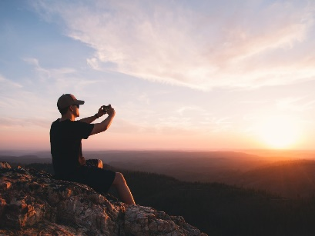
This is a terrible photo, I will edit it.
Please edit this photo.Change this photo.
Please replace the recurring expression “This is a”!

